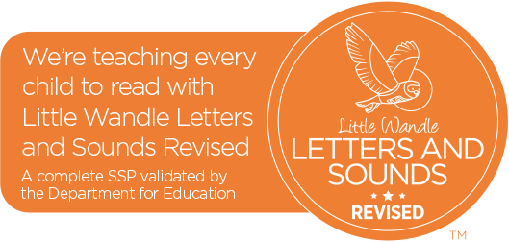

Little Wandle Fluency Reading
Your child is now ready to move on from the Little Wandle Phonic Programme as they have a secure knowledge of the Phonic Code.
At Earlsdon Primary School, we are pleased to tell you that we have invested heavily in the next set of reading practice books from Little Wandle to develop your child’s reading Fluency. You will notice that these books consist of six short chapters, that gradually increase in terms of quantity of words and challenge to build reading confidence, stamina and speed and nurture a love for reading.
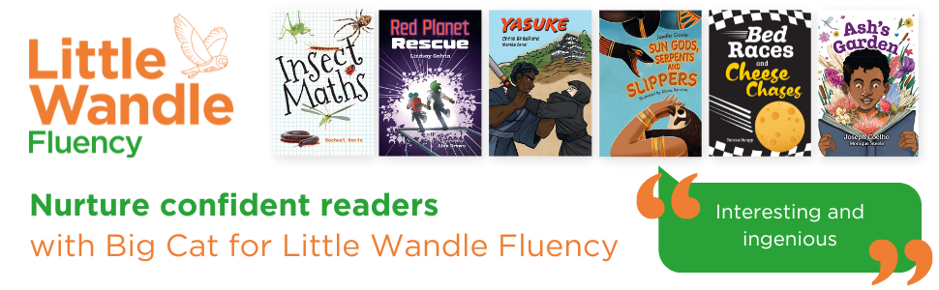

What’s different?
- Your child will read a Fluency book over two/three weeks not one week.
- They will focus on two/three chapters per week.
- Access may be necessary through the Big Cats Reading platform.
What’s the same?
- Your child will learn new vocabulary pertinent to the chapter.
- They will read fiction and non-fiction books.
- They will be taught how to read with prosody.
- They will be asked and taught key comprehension skills.
- Children will be assessed periodically to re-assess their fluency and prosody.
- Children will continue to choose a ‘sharing book’ to develop their reading interests which they may be able to read by themselves.

What can you do to help?
Continue to listen to your child read. It’s the most important thing you can do!
Your child will have read the chapters in each of their reading lessons.
Example – Week 1 Chapter 1-2.
Week 2 Chapter 3-4.
Week 3 Chapter 5-6.
Please only repeat the chapters that have been read in school, do not go ahead as the children need to focus on these chapters a bit at a time, no matter how tempting that might be!
Discuss any key vocabulary that they may not understand.
Make them aware of other books written by the same author.
If you have a physical book, please return it every day as we have a limited supply of these books in school. Please note that if these books do get damaged or lost then £7.00 will be charged.

Thank you for your continued support. If you would like to ask any further questions about this then please speak to your class teacher.

