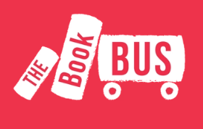
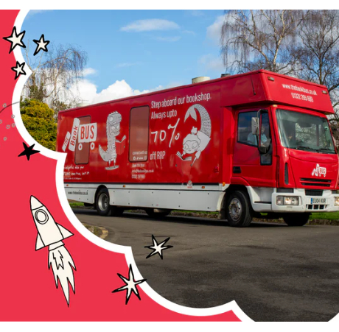

Dear Parents / Carers,
We are very excited that The Book Bus will be arriving in school on Friday 25th September for one day only! The Book Bus is a mobile bookshop aiming to bring high quality, affordable books to each corner of the country.
With over 300 titles and collections onboard, there is something for everyone on The Book Bus.
Ways to buy:
Children will be taken on board the bus in their classes. They can then buy books on the day with their classmates.
The bus will also be open to parents and children after the school day until 4pm on the school car park.
- Your child’s class will be able to browse and purchase books on the day.
- Please use this link to browse books that will be available
- The Book Bus - Come back ⚡
- Send your child into school with CASH or downloadable VOUCHERS ONLY in a sealed envelope with their name and class. (no more than £10.00 is advised)
https://thebookbus.co.uk/products/the-book-bus-gift-card-15
- Siblings should have separate envelopes.
- Books range from £3.00 upwards. Children can also purchase stationary items such as pencils, rulers, rubbers etc
Please support our travelling book fair, money earnt will be spent back on books for the children.

Thank you



